**Student Questions**

Learn about the internals of a standard PC case by examining physical samples and selecting and labeling images found on-line. Gain deeper knowledge by researching and reporting on specific components.

PC Tower Case

1. Find one (or more) images that clearly show the internals of a PC Tower Case.   
   (i.e. Google images using keywords “PC Case Internals”)

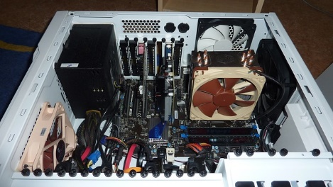

1. Clearly label the following components (using arrows) on your image of the PC case internals:

Optical disk drive

Motherboard

Cooling fan

Monitor ports



Hard disk drive

Audio ports

Ethernet port

* 1. Motherboard
  2. Power Supply
  3. Hard Disk Drive
  4. Optical Disk Drive (e.g.DVD)
  5. USB Expansion Ports
  6. Monitor Port
  7. Audio Ports
  8. Ethernet Port
  9. Cooling Fan

1. Research more in-depth about “Hard Disk Drives”. Make notes on the following:
   1. What different versions are currently available (speed and capacity)

* IBM 350 RAMAC, capacity 5Mb
* PATA
* SATA
* SCSI
* SSD
  1. How the capacity of the component has changed since the 1980’s

Now they have more space and have gotten smaller and slimmer since then.

PC Motherboard

1. Find one (or more) images that clearly show the layout of a PC Motherboard.   
   (i.e. Google images using keywords “PC Motherboard”)

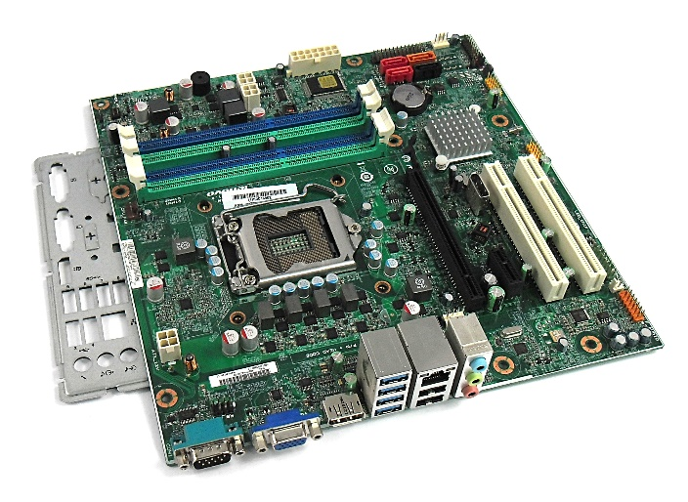

1. Clearly label the following components (using arrows) on your image of the PC motherboard:



RAM Memory

CPU and fan

SATA

Sound processor

Wifi processor

* 1. CPU (and fan)
  2. RAM Memory
  3. Disk Drive Interface (IDE or SATA)
  4. GPU Graphics Processor (either on-board or Graphics Card)
  5. Sound Processor (either on-board or Sound Card)
  6. Wi-Fi / Ethernet Network Interface (either on-board or Graphics Card)

1. Research more in-depth about “CPU Processor Chip”. Make notes on the following:
2. What different versions are currently available (speed and capacity)

Currently there are many cpu processors that are available. One processor is the intel core. There are many different versions of this like intel core i3, i5, and i7. The ones with the higher number are better since they are faster and more powerful than the lower numbers.

1. How the speed of the component has changed since the 1980’s

The cpu processors in the 1980s had a clock rate of 4 – 8 MHz but now the best processors come with 5 – 6 GHz clock rate. 1 MHz is equal to 0.001 GHz.

Peripheral Devices

1. Find one (or more) images that clearly show the layout of the back of a typical PC tower case.   
   (i.e. Google images using keywords “Back Of PC Tower”)

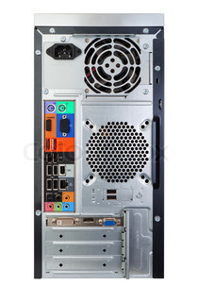

Power cord

Audio input

USB ports

Ethernet port

Mouse interface

And keyboard interface

Monitor port (VGA)

1. Clearly label the following components (using arrows) on your image of the back of a typical PC tower case:
   1. Power cord and power switch
   2. Monitor Interface (VGA or DVI or HDMI)
   3. Mouse Interface (USB or PS/2)
   4. Keyboard Interface (USB or PS/2)
   5. USB Ports
   6. Audio Inputs / Outputs
   7. Ethernet Interface

1. Research more in-depth about “External Portable Storage”. Make notes on the following:
2. Floppy Disks

* Type of disk storage
* Read and written by a floppy disk drive
* Not used anymore

1. CD-ROM / DVD / Recordable CD/DVD

* Cd rom and dvd are disk drives with data already in it which cannot be erased or changed.
* Recordable cd and dvd are disk drives that are blank and you are able to put your own data in it
* You can play cds on a computer or cd player

1. USB Memory Drives

* A storage device that is rewritable which means data can be added and removed from it
* They are smaller than cds and floppy disks but can hold more storage
* Easier to carry around

1. Compact Flash Memory

* A type of storage used in electronic devices
* Can be used in cell phones to add storage or cameras
* Compact flash memory is still popular today

1. Cloud Based Storage

* A type of storage where you store stuff online instead of storing it locally on a physical device
* This type of storage can be accessed anywhere as long as you have an electronic device and internet
* Most popular type of storage today since you don’t need to carry around anything physical

**Presentation Outline**

Explore the development and features of a specific PC hardware component through deeper research and investigation. Work in partners to create a short presentation. Deliver the presentation to the class.

Each group will research a unique PC hardware component. Your specific topic will be assigned from the list provided below.

**Presentation Structure**

1. Explain what the PC component does and how it fits together with other components to make up a fully functioning PC.
2. Explain how the PC component works. Provide a diagram (image) showing the main parts of the component.
3. Research the current state of the art of the component in terms speed, capacity (size), and other related factors.
4. Research on-line suppliers that sell the PC Component. List the specifications for the available products and the cost (price).
5. Research how the PC component has changed and evolved since the early days of PCs in the 1980’s. Cover each of the following topics separately:
   1. Component Speed
   2. Component Size / Capacity
   3. Two other specifications specific to the PC component (ask Mr. Nestor)

**PC Component Topics**

|  |  |  |
| --- | --- | --- |
| **Topic** | **Partner 1** | **Partner 2** |
| CPU Microprocessor Chip |  |  |
| Motherboard Layout |  |  |
| Computer Graphics |  |  |
| Sound & Audio |  |  |
| Hard Disk Drives |  |  |
| Removable Disk Storage |  |  |
| Ethernet / Fiber Connectivity |  |  |
| Wifi / Bluetooth Connectivity |  |  |
| Mouse / Pointing Devices |  |  |
| Monitor & Display Technology |  |  |
| Printers & Output Technology |  |  |